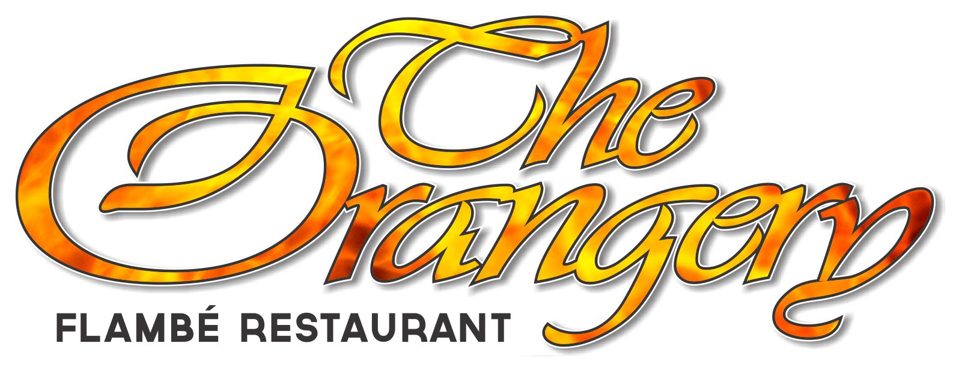 |   Please note 15% surcharge will apply on public holidays

Breads

Garlic bread 10
Gluten free garlic bread 12
Caramelised onion, feta, pizza bread 14

Small Plates

Mushroom pate, walnut, sesame parmesan cracker, toasted baguette V 20
Fried crispy rice cake, honey glaze chilli crunch, kewpie V 20
Creole prawns, tomatoes, green peppers, cajun butter GFA 21.9
Cured salmon, pickled daikon, sweet mustard, kavring rye GFA 21.9
Calamari, chilli ginger, scallion, squid ink, roast garlic aioli GFA 20

Beef brisket pho, charred aromatics, bean sprouts, chilli, lime 16
Bay of Island Pacific oysters, white balsamic mignonette $3.50 each
Kilpatrick oysters $4.00 each

Flambé Mains - cooked at your table

Chateaubriand for two eye fillet pan seared,
flambéed with brandy finished with mushrooms, peppers, red wine jus, 129
served with seasonal vegetables & potato pave

Steak Diane butterfly cut eye fillet pan seared,
flambéed with brandy finished with mushrooms, peppers, red wine jus, 49
served with seasonal vegetables & potato pave

Prawns garlic pan seared, flambéed in Pernod
finished with white wine, cream & butter sauce,
served on steamed rice & seasonal vegetables 45

Flambé Dessert

Crêpes Suzette, crêpes warmed in a caramelised sauce,
flambéed with Grand Marnier served with vanilla ice cream GFA 22.9

Please note 15% surcharge will apply on public holidays

Large Plates

Fish n chips crispy batter, fries, tartare sauce 39
Fish of the day changing daily, refer to wait staff GFA 40
Chicken breast panko coated, tomato, roast walnut, feta 39
Duck l’orange, crisp roast, torched orange jus 49
Ribeye garlic butter, mushroom sauce 45
Beef brisket pho, charred aromatics, bean sprouts, chilli, lime 33
Porchetta pork fillet bacon, apple brandy, green peppercorn cream 45
Lamb en croute, shortloin, mushroom duxelles, flakey pastry, green peas, shallots 49
Chorizo risotto braised fennel, black garlic parmesan crisp 39
Bami goreng, stir fried noodles, tofu, cashew, chilli crunch V 35

All mains served with seasonal vegetables & potato pave’

Side Dishes
Fries 9 Green salad 9 Onion rings 10 Vegetables 9

Desserts
Lime cheesecake, whipped coconut 20
Chocolate fondant 20
Champagne grapefruit jelly, grilled pineapple, hokey pokey icecream 20
Rhubarb creme brulée 20
Cheese selection, crackers, accompaniments per person 22

Coffee / Tea
Long black, flat white, cappuccino, latte
Short black, hot chocolate, cafe mocha From 5
English Breakfast, Earl Grey & fruit teas 5

Liqueur coffees a selection of liqueurs with freshly brewed coffee & cream
Calypso coffee Kahlua, coffee & cream 16
French coffee Cognac, coffee & cream 16
Irish coffee Jameson’s whiskey, coffee & cream 16
Irish cream coffee Baileys, coffee & cream 16
Italian coffee Amaretto, coffee & cream 16

Please inform your waiting staff of any special dietary requirements

